**PROJECT 2:**

**FlyAway(An Airline booking portal)**

**Sprint Plan:** No of Sprint-3, Duration-21days.

Sprint 1: Prepare a flow chart of the application and core concept, algorithm. Prepare separate git repository and update each and every work.

Sprint 2: Create wireframe for an application. work on admin portal and User page.

Sprint 3: Verify/Test application functionalities and Update it in git. Then create all documentation about the project.

**Flow of the Application:**

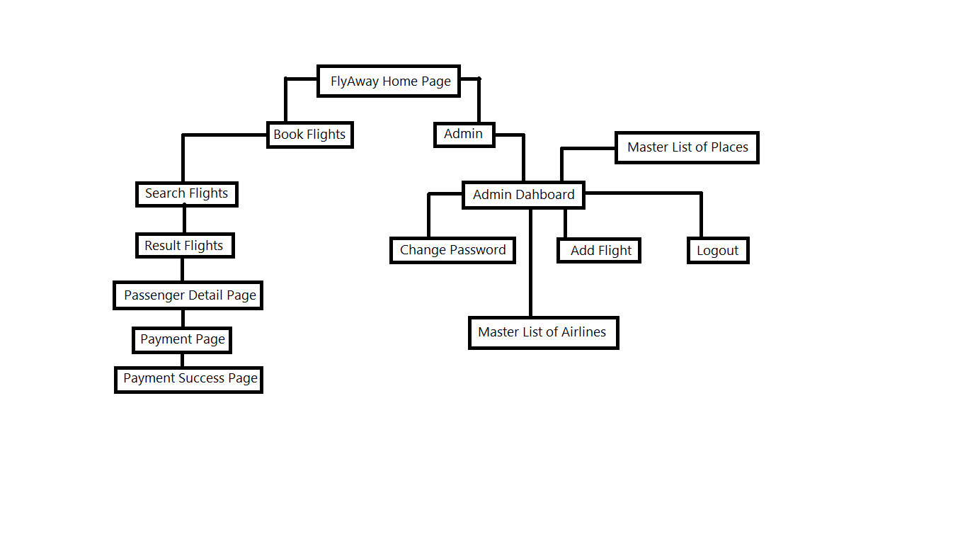

**Algorithm:**

1. Run the Application on Tomcat server.
2. Home Page of the FlyAway web portal is displays. It has two options one for admin and another for users to book flight.
3. If we click Admin button is will redirect to admin login. Here we need to enter valid admin entities then only we have to move over to the admin portal.
4. After login to the admin portal there is master list of flights, source, destination, date and ticket price all the details will be display.
5. Change password option is there if we need to change the password for the admin login, can able to do that.
6. Add Flight option is used for add new flights into the data base.
7. And similarly Master list of places, Master list of Airlines are there for see the needed details seperately.
8. Logout option for return to main menu(Home Page)
9. Book flights Page we need to enter our flight date, source point, destination point and Number of tickets.
10. After submit the result it will display result flights with all Ticket price. We can able to book the needed flight by click on book flight button.
11. It will be need user/passenger detail for book flight. After enter the passenger detail it will redirect to dummy payment page. Here you need to enter the payment details then it will book your flight and return the success page. You can able to download it.

**Login Credentials:**

**For Admin:**

Userid/username – **admin**

Password – **123**

**Database Detail:**

Here I’m Using **JDBC** with **AWS** so *don’t need to create a Database* at client side. The Database for FlyAway was already created in AWS it is accessible at anywhere and anytime.

**Instruction for work on Application:**

1.Add the Application File into the eclipse add Tomcat server and Mysql jdbc connector and other dependency libraries.

2.Run the Application on Tomcat server.

3.In Home Page we have two options

*Book Flight

*Admin

4.In Book Flight option User can able to book their flights and Admin option for Administer to manage a portal.

5.In Admin portal we can able to see all flight details and able to add new flights into the database and can able to change the admin password if wish.

6.In Book Flight page we need to enter the date, source, destination and no of passengers for filter the flights for particular date. If flights not available for particular date then it will show empty in result flights page.

7.We can choose our flights from filtered result by book flight option.

8.Then we need to enter passenger details and card/payment details for book a flight.

9. If successfully complete the forms then final success page will be displays, we can able to download the receipt for booking.